**FIRST PROJECT SUBMISSION (Group13 project 3)**

**Requirement Gathering**

**STORYBOARD**

**Miro Storyboard Link:** <https://miro.com/app/board/uXjVP3ICRlw=/?share_link_id=788872327322>

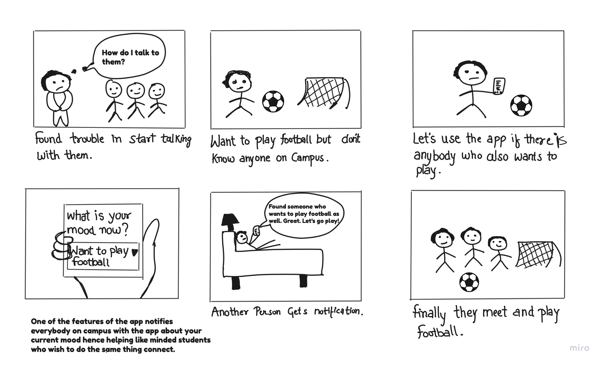

**MINDMAP**

**Miro Mind Map Link :**

<https://miro.com/app/board/uXjVP3bKp4I=/?share_link_id=646388709851>

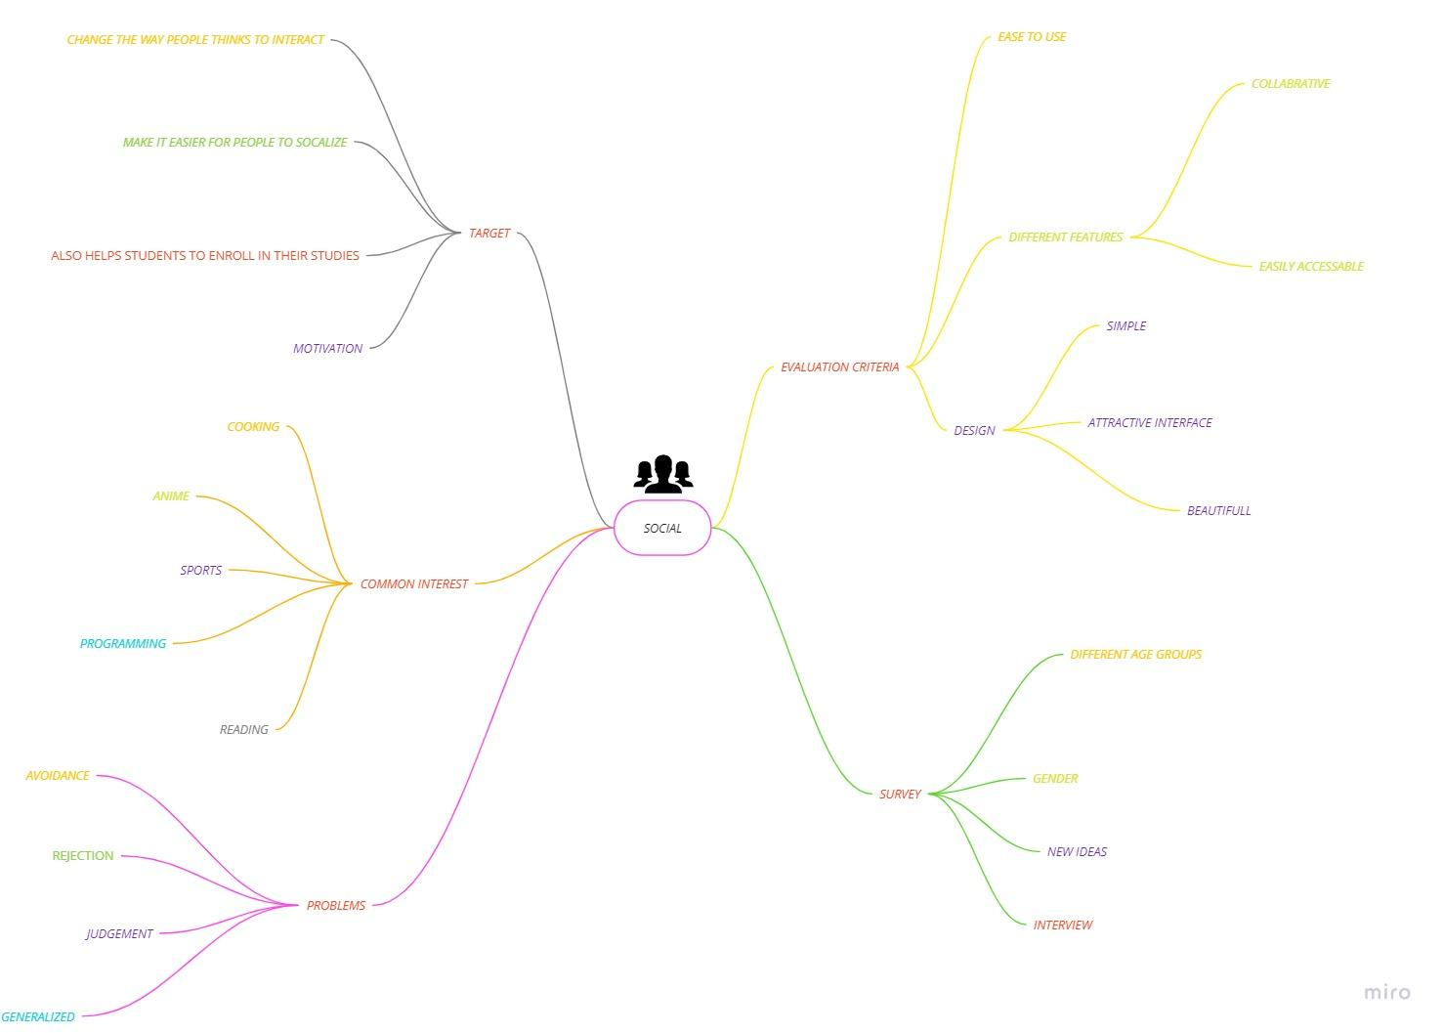

**Survey and Some Crucial Takeaways**

**Responses of every Individual:** [Reticent (Responses)](https://docs.google.com/spreadsheets/d/1K1i7P8XIJEHPgTM1MtGWGH5VrpOCzaIpkcbxhMWucSc/edit?usp=sharing)

1)**Getting user feedback and involving them in the design process is not an as easy task as we thought it earlier**

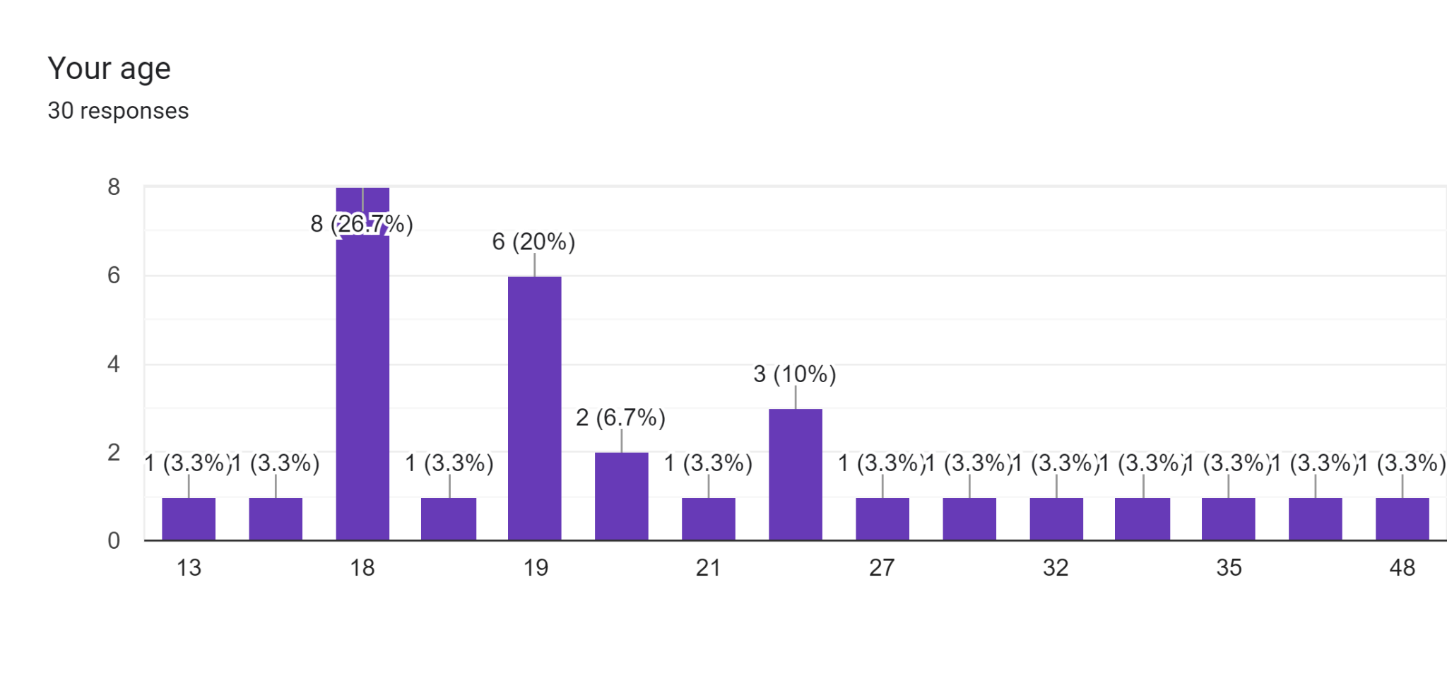

2) **People of different ages and Different sex people took the survey. So we could have diverse feedback on our idea**

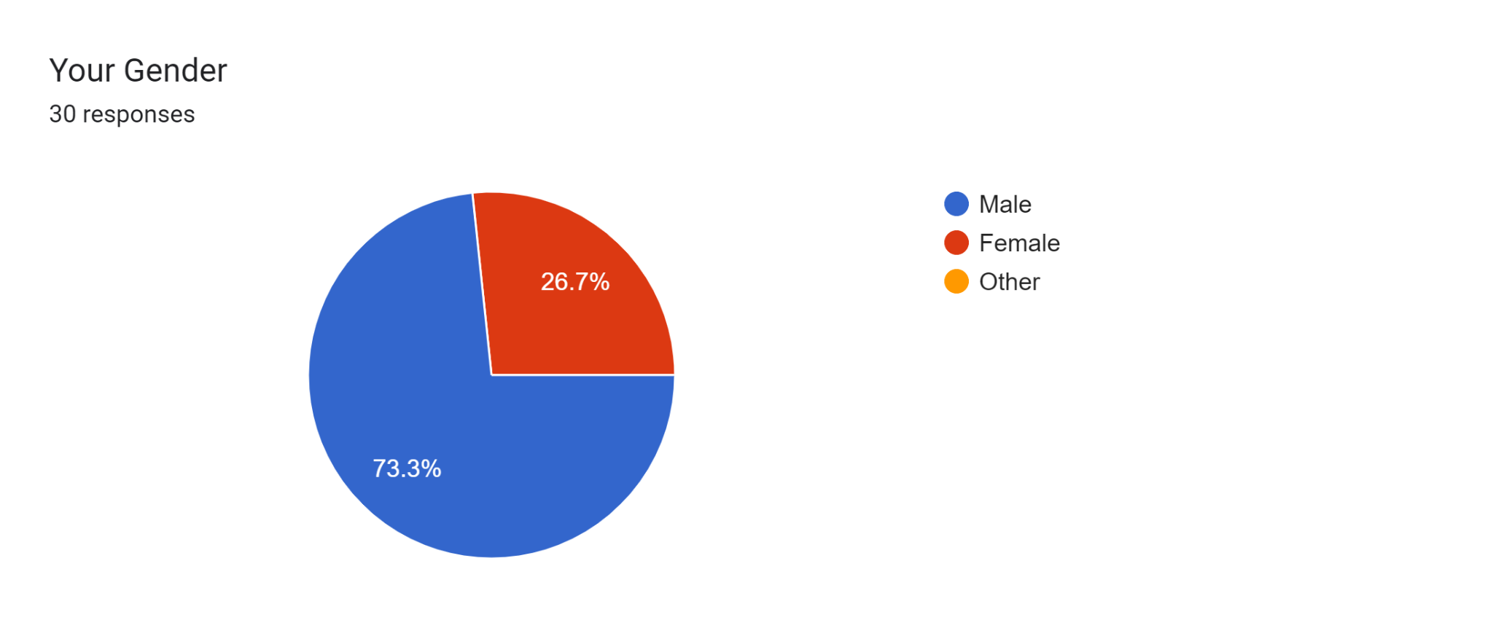

3)**Majority of people regret losing opportunities to communicate, as we thought earlier, so our assumption was correct**

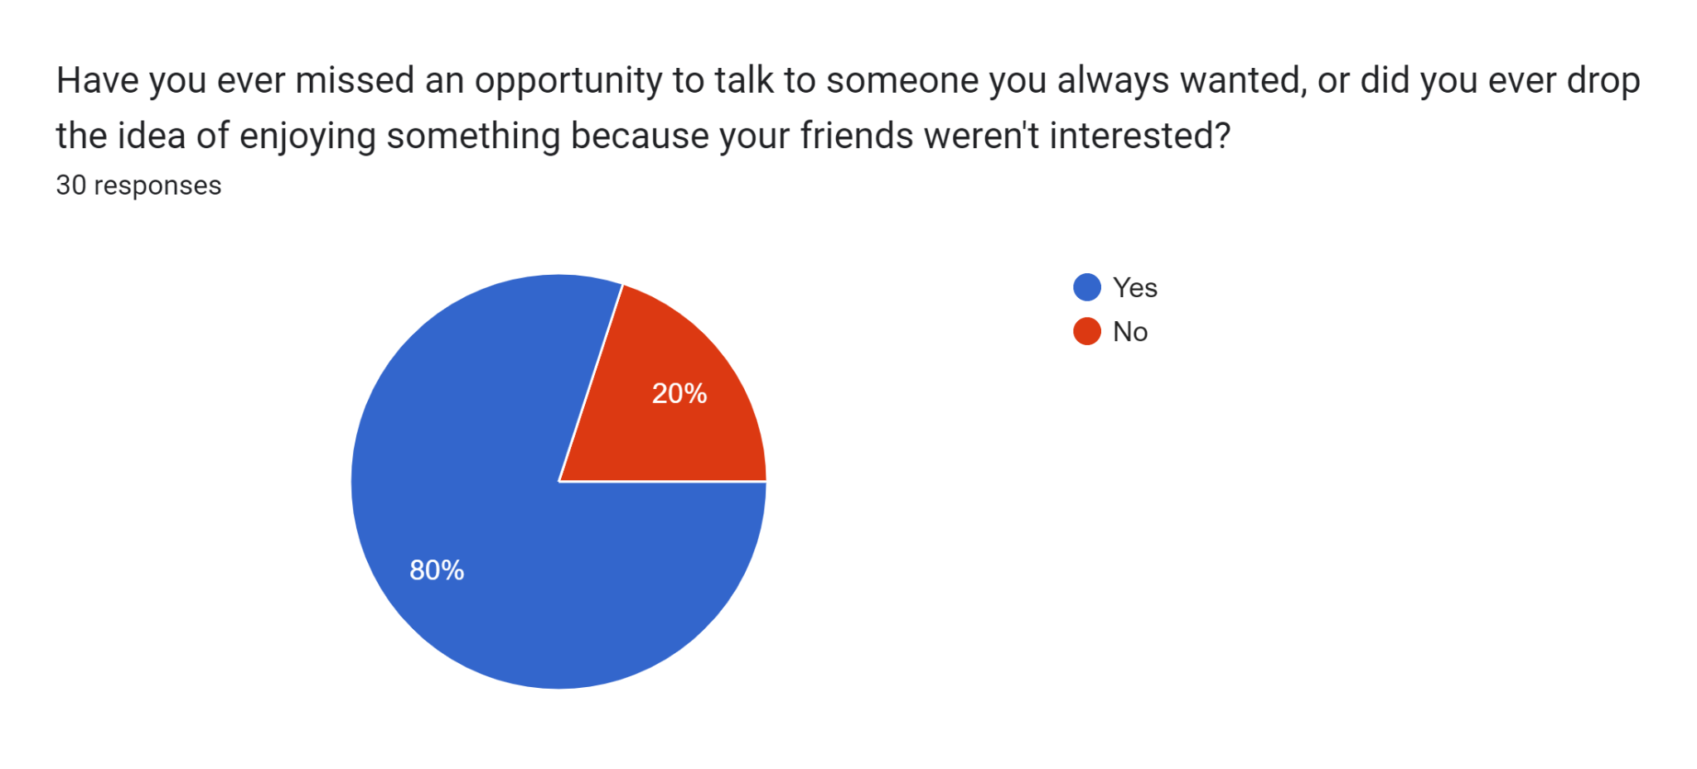

3)**The majority of people want to have friendships with their kind of people, so our assumption was correct, but for few who even want to connect to different diverse types of people, we could add another feature in the app!**

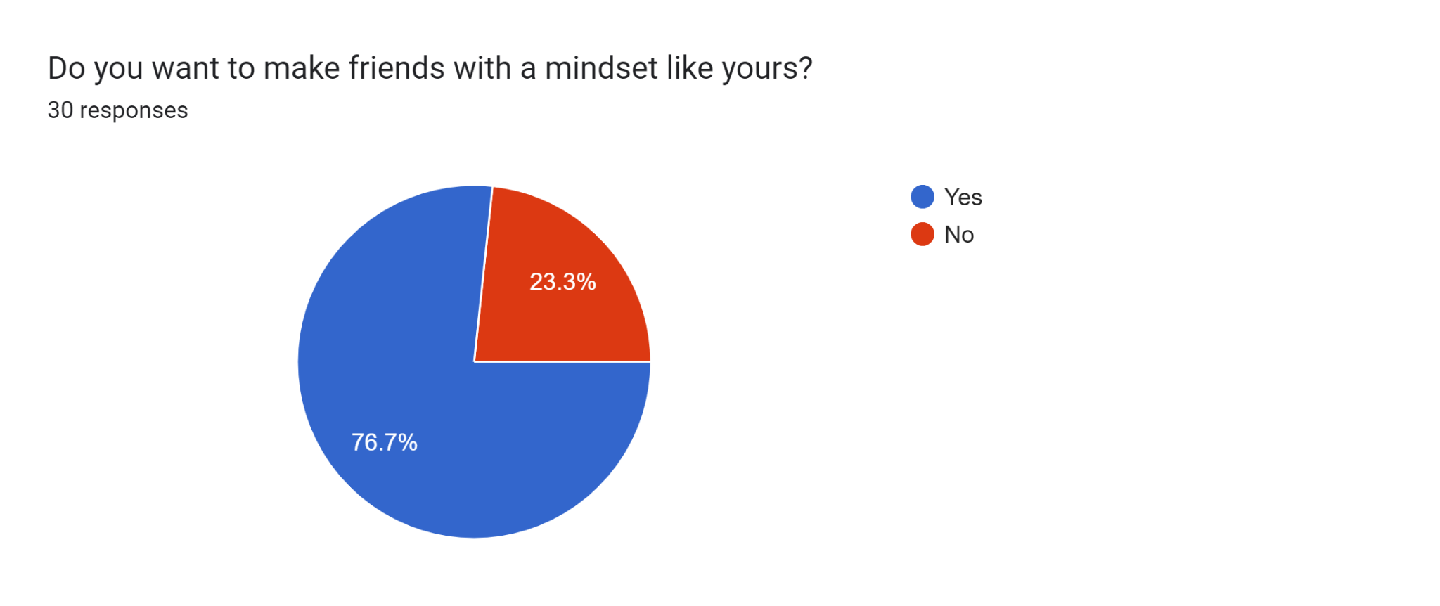

4)**Only a few, after listening to our idea, said directly no to our vision so our concept could be taken to the following levels**

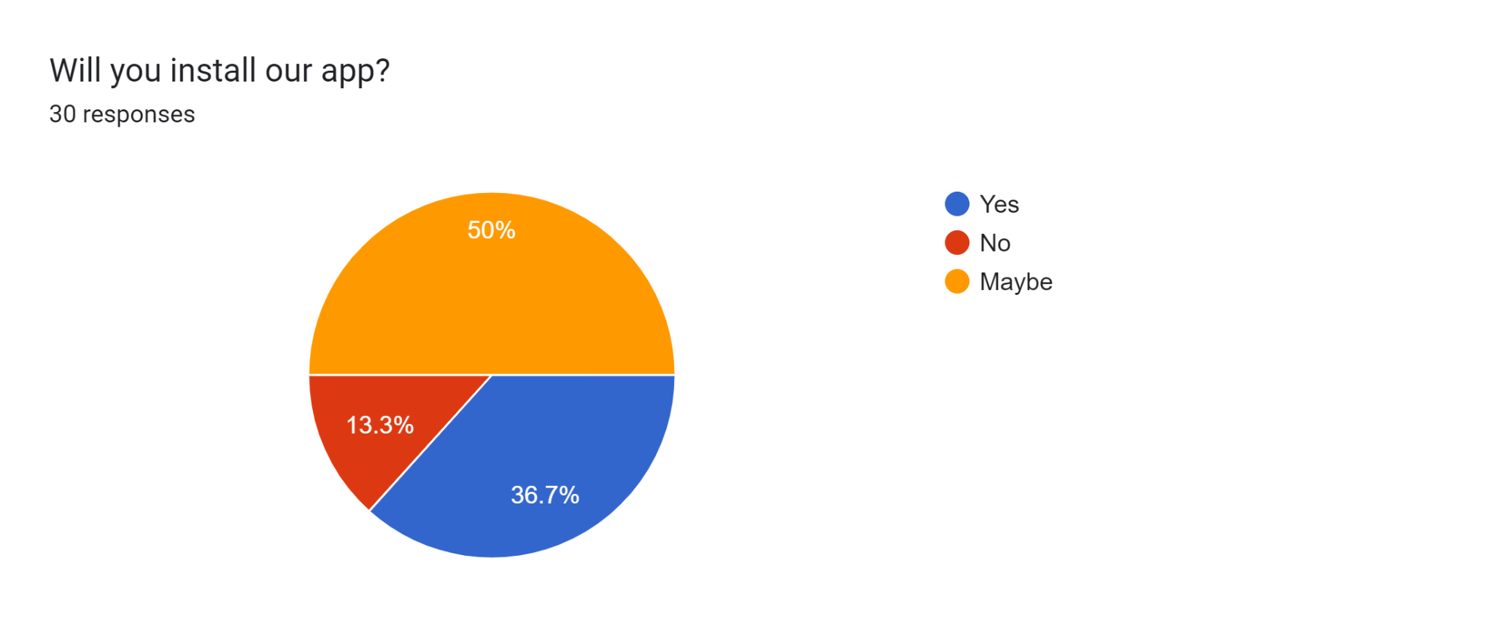

5)**We got an average rating of 3.8 and a median rating of 4 for our idea.**

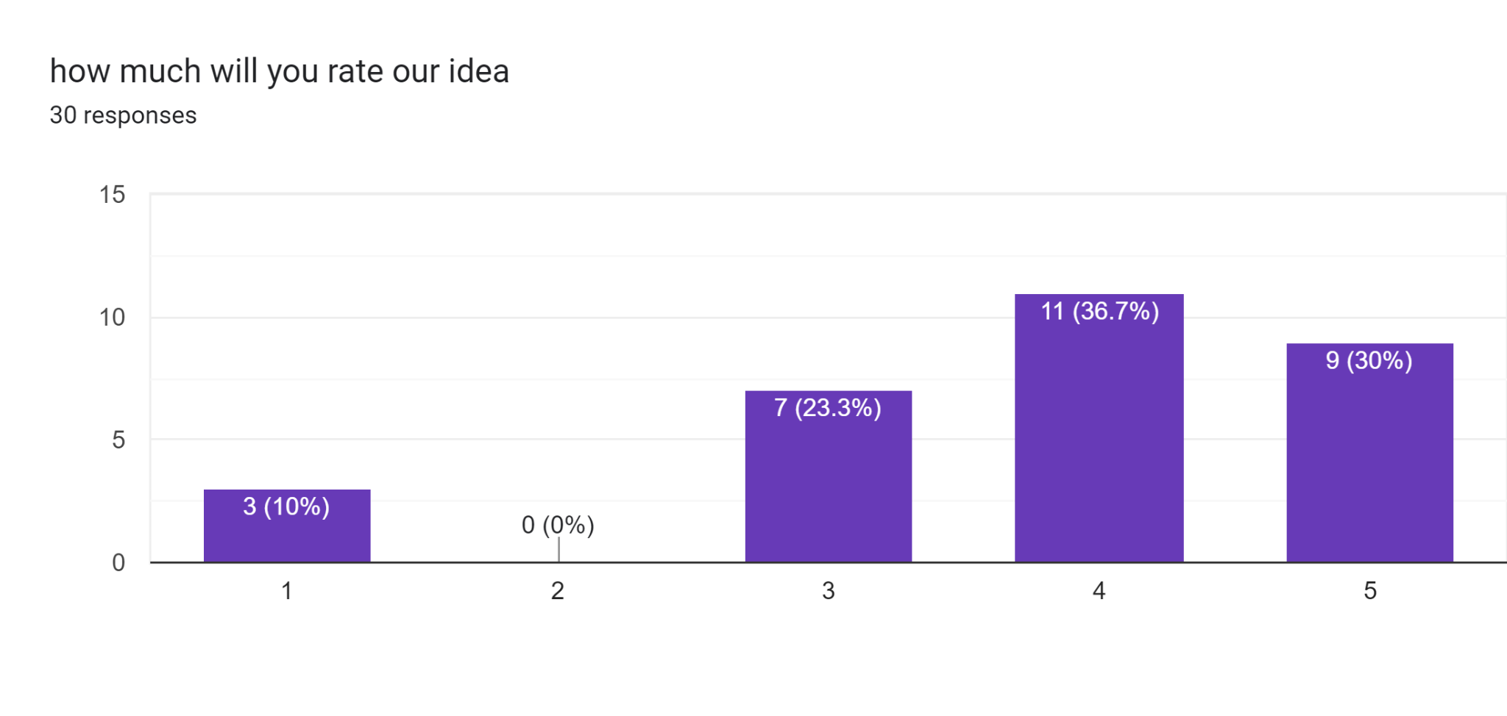

6)**We saw a positive response on whether people will share our idea.**

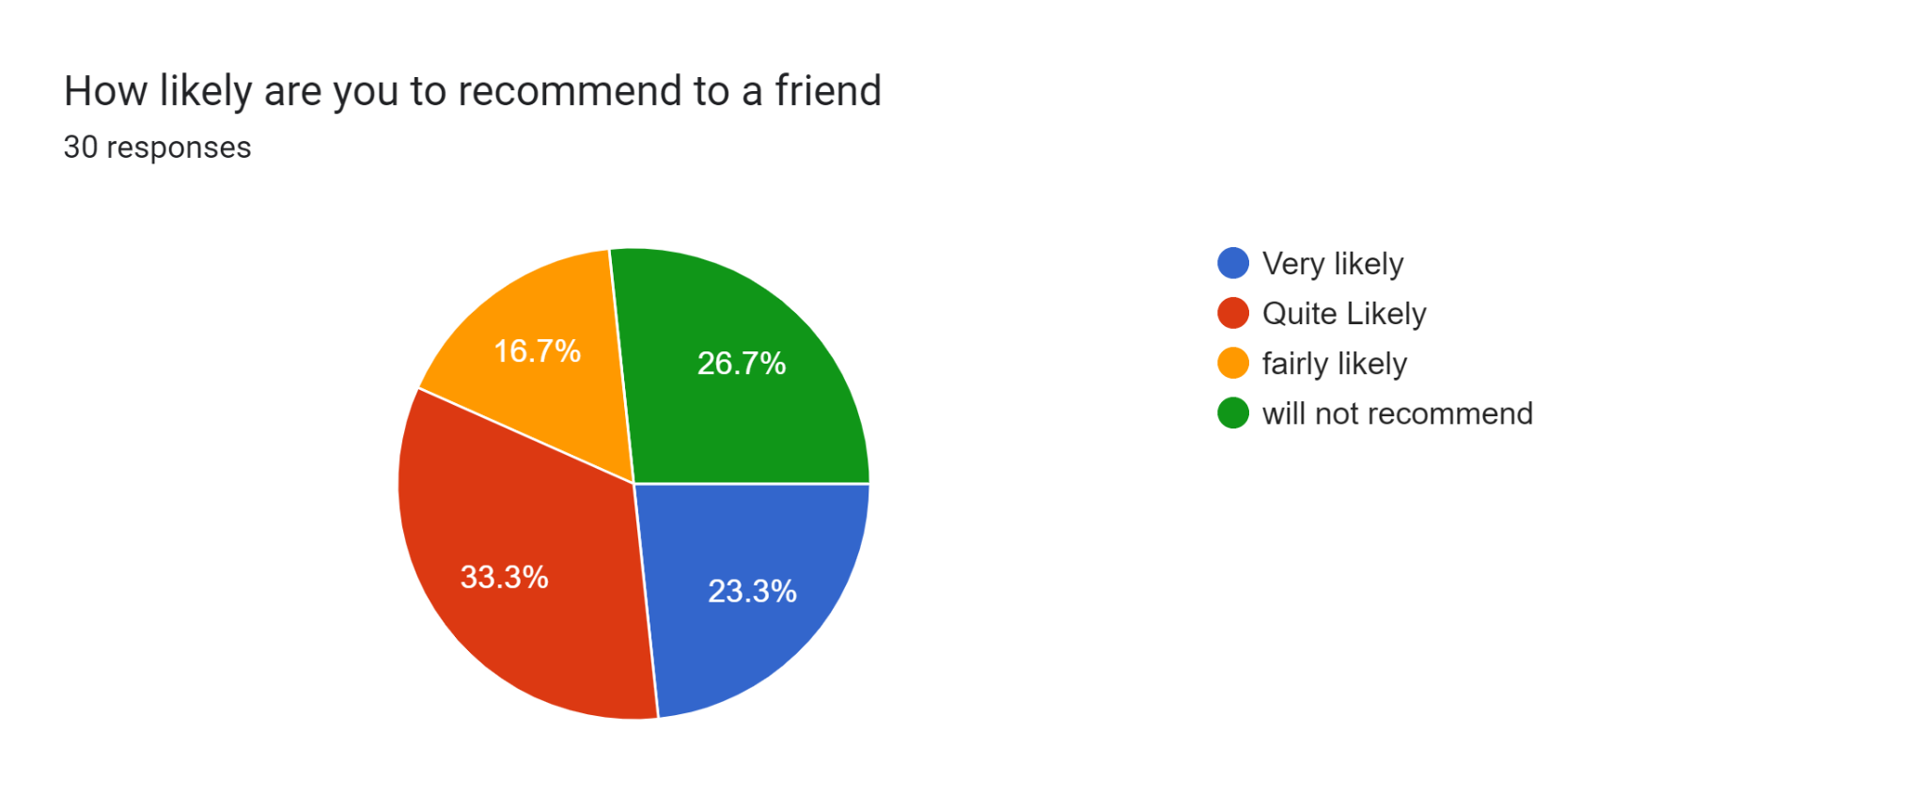

7)**Most people think they are introverts, and our idea is mainly for introverts!**

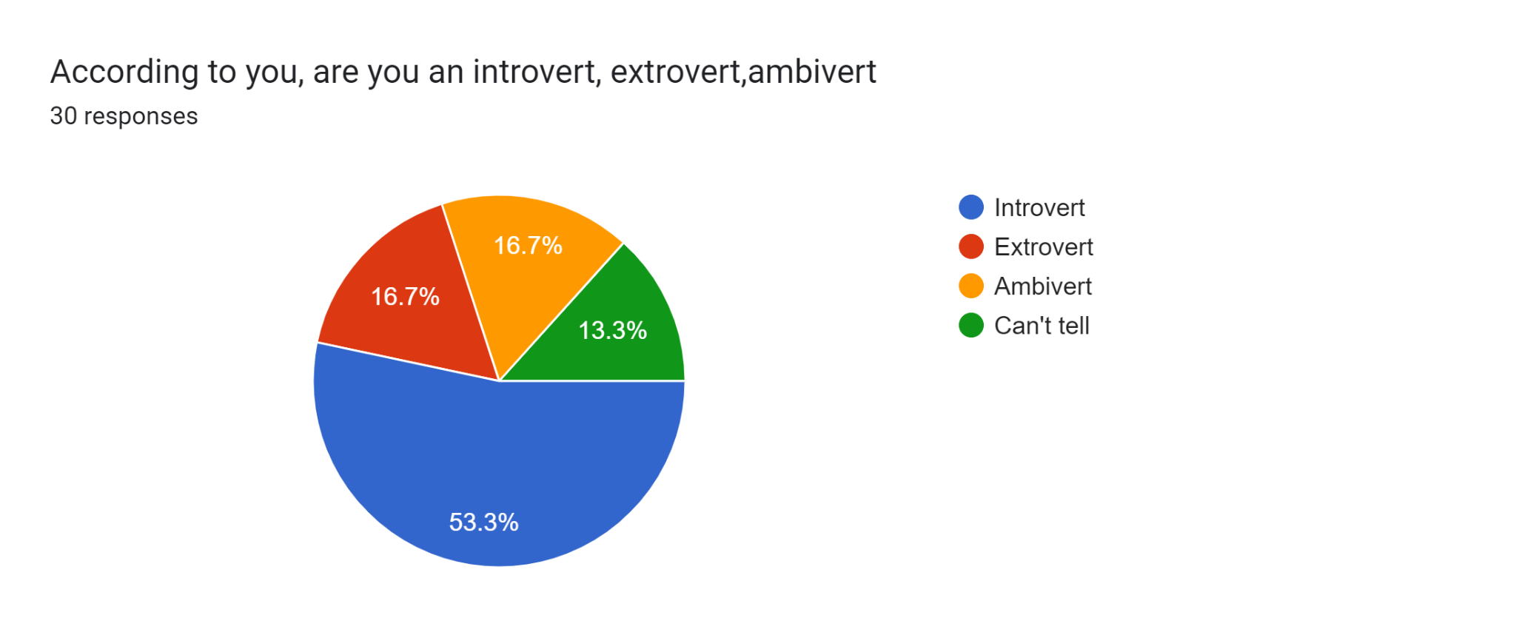

8)**Things we should keep in mind while developing UI.**

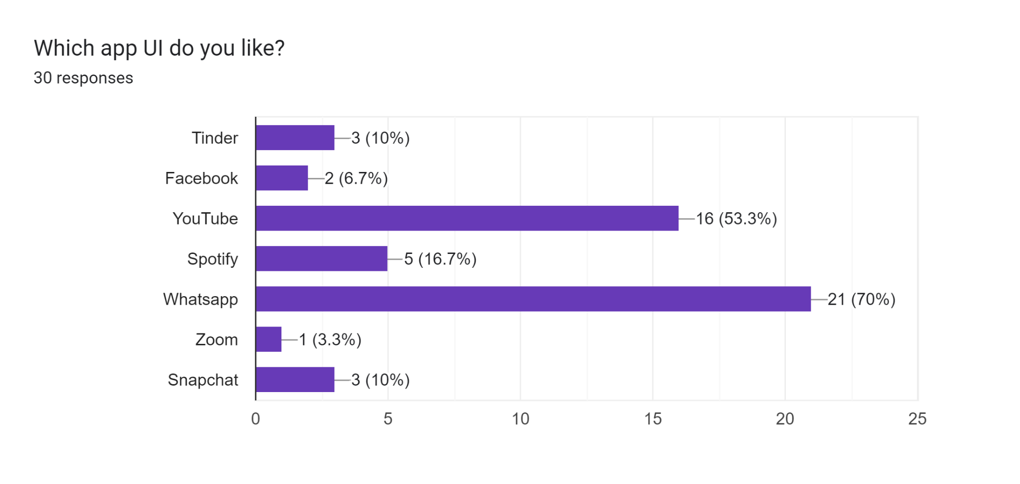

**Personas and Scenarios**

**Personas**

Personas Miro Link:

<https://miro.com/app/board/uXjVP3SjeIo=/?share_link_id=634221683898>

1)

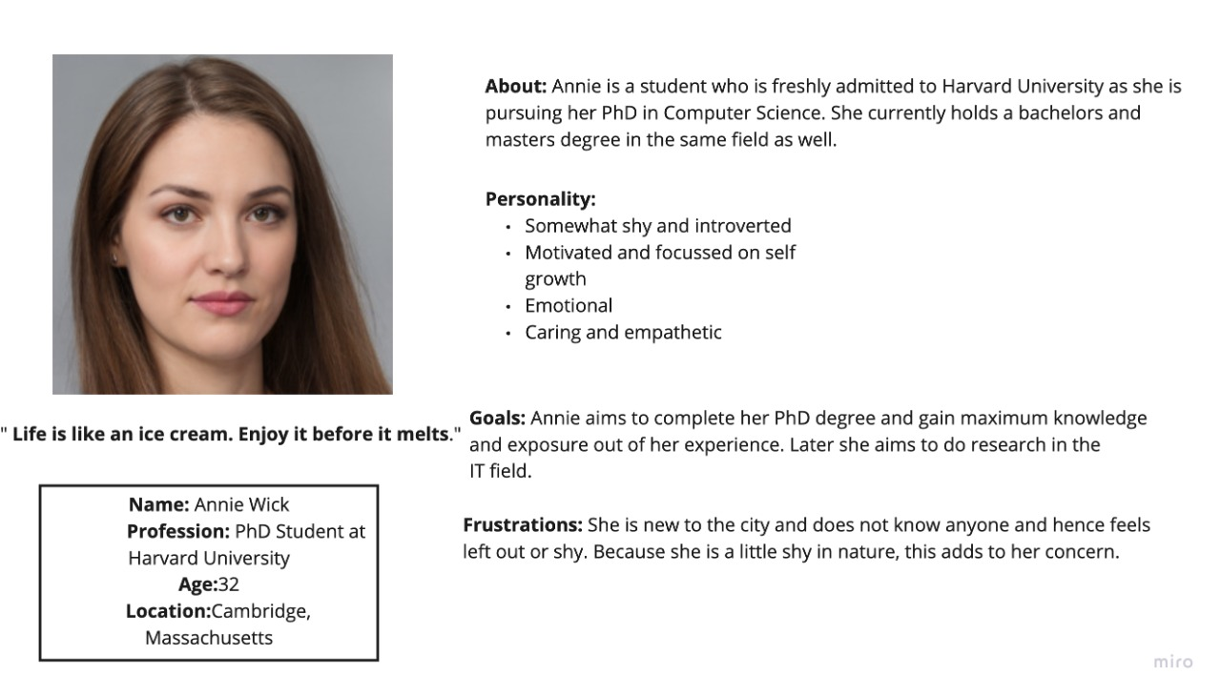

2)

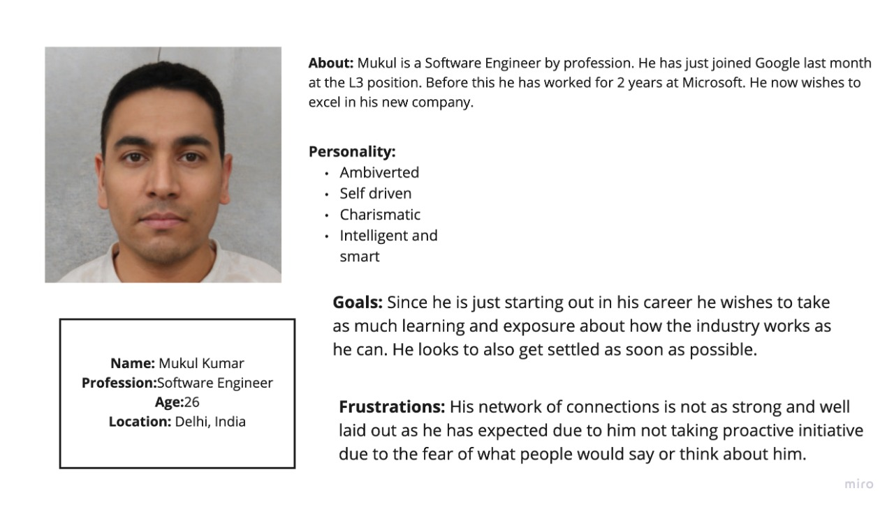

3)

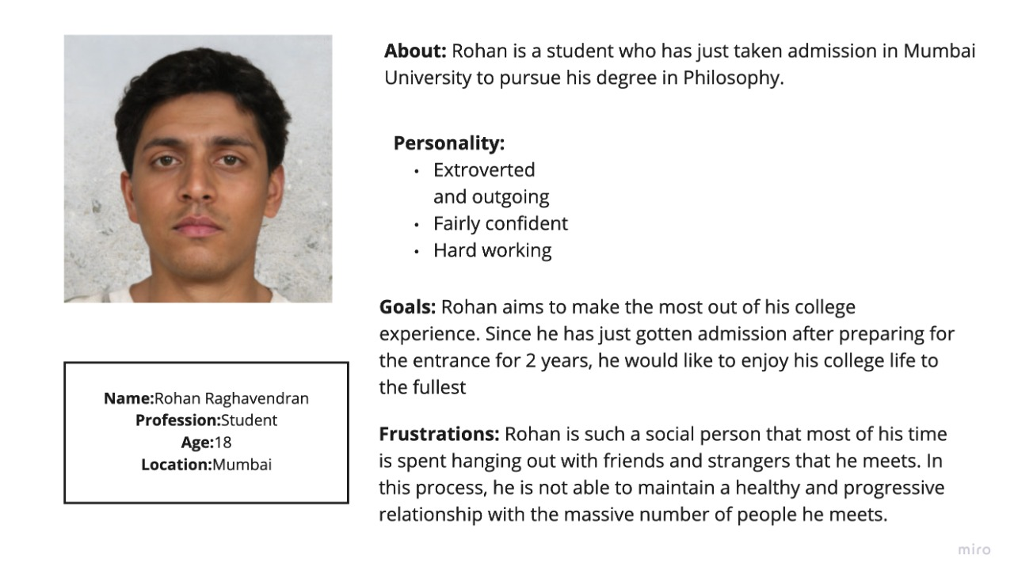

**Scenarios**

Scenarios Miro link:

[**https://miro.com/app/board/uXjVP3aRues=/?share_link_id=914485726345**](https://miro.com/app/board/uXjVP3aRues=/?share_link_id=914485726345)

1)

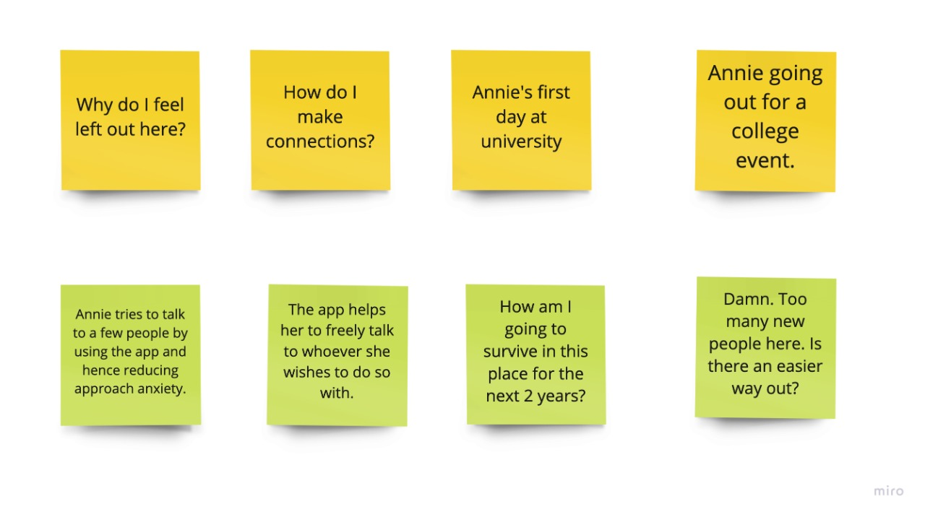

2)

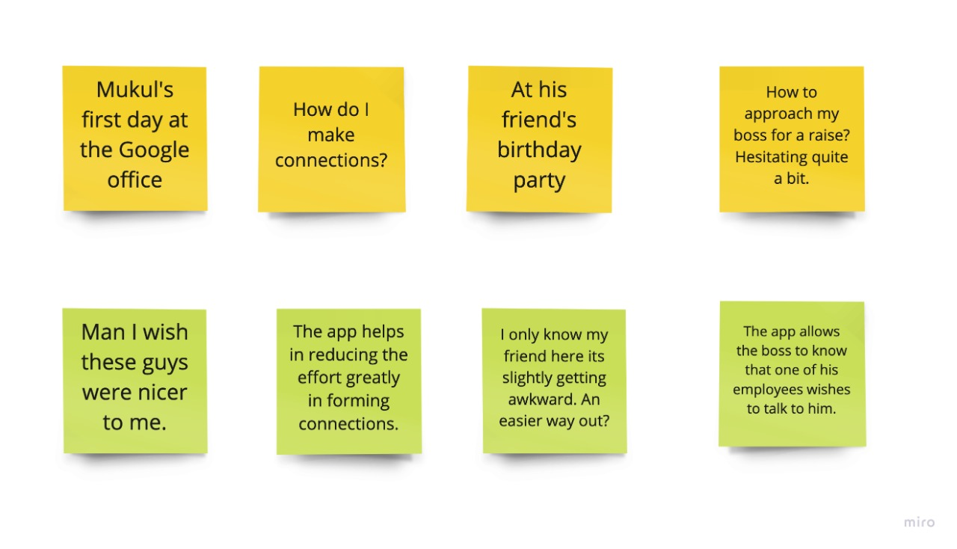

3)

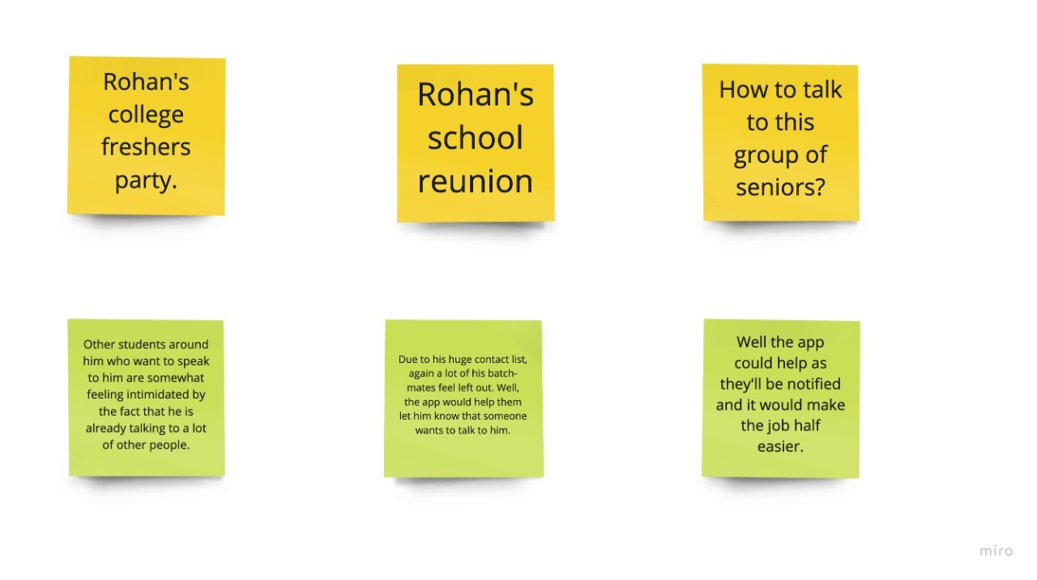

**Problem Understanding**

**Proposed solution**

The project solution aims to connect people more efficiently. Through experience in the past, we have seen that the apps which had made connections efficiently are worth a billion or trillion dollar companies like Facebook (meta), Instagram, LinkedIn, Whatsapp, Telegram, Snapchat, Tinder, and Omegle are just too few to name examples. Our project initially aims to connect person A to any random person B or a group of people they see passing by without them having to take all of the initiatives, making the job easier. If person A wishes to talk to person B, they will get notified if they both are under the same radar. As the world revolves around connections, there are high stakes that person B will acknowledge person A'sA's wish to communicate, which can make all the difference in them opening up to you and possibly forming connections for life! These projects will be expanded to every college, school, workplace, hotel, restaurant, etc. We are also considering creating a feature that helps like-minded individuals connect at that moment. Suppose person X wishes to play football at 11 at night but knows no one else who wants to do the same. We are considering starting from our college IIITD for alternative prototyping solutions. There's no upper limit, as we could cover different colleges and the general public. The solution will be achieved through a mobile application that will take the user's mobile number, locations, profile photos, and some information on their interests and achievements they have succeeded in life.

**Target User**

Target users will include college students, school students (teenagers), people living in apartments, and companies. The Target users can be considered a union of Instagram, zoom, and Tinder users.

**Specific Requirements:**

1. Intuitive UX is something that can popularize our app, so we need a great UX designer
2. Platform integration is key to attracting users, so we need a few people who can help us collaborate with big companies and could mentor us
3. Innovative features are an integral part of the functioning and appearance, so we need a UI designer
4. we also need a Project Manager, Analyst, Product Owner, and marketing people for the app
5. For app development and constant update fixes, we will need Front-end and Back-end Developers
6. we will also need a team who can take user feedback and tell them to work on it accordingly
7. Finally, most importantly, we need a good amount of money and a few users on whom we can test our app

**Credits and Contributions:**

**Krish Kumar Bhoruka:2022253**

Attended all meetings, did the survey and mind map for the project.

**Krishna Shukla: 2022254**

Organized and attended all meetings. did the whole problem understanding, survey, and whole documentation for the project and helped in other works.(major contributor)

**Krishnendu: 2022255**

Attended all meetings, did the mindmaps and storyboard for the project.

**Kshitij: 2022256**

Attended all meetings, did the mindmaps and storyboard for the project.

**Kshitij Gupta:2022257**

Organized and attended all meetings, did the whole personas and scenarios of the project and helped in other works.(major contributor)